Milwaukee Community Brownfields Workshop

Robert Hersh
Center for Public Environmental Oversight (CPEO)
December 2007

On Saturday morning, December 8, 2007, 35 people braved 8º F. temperatures to attend a community brownfields workshop in Milwaukee, Wisconsin. The workshop, convened by the Good Jobs and Livable Neighborhoods Coalition (GJLN), a local community-based organization, and CPEO, focused on cleanup and redevelopment strategies for one of the key brownfield properties in the city—the sprawling, former A.O. Smith manufacturing complex. For a hundred years, from 1906 until 2006, generations of Milwaukee workers built car and truck chassis and other components for Ford, Chrysler, and General Motors on 150 acres in the north of the city. Now, as is evident from the picture below, most of the buildings and factories on the site are vacant.

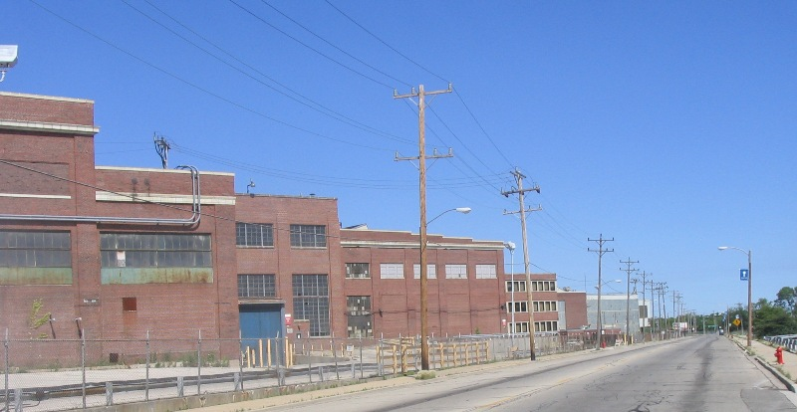
Former A.O. Smith Plant
A.O. Smith—An Industrial Mainstay
For many community residents who attended the workshop, A.O. Smith was once a source of good jobs and economic opportunity for themselves, their family members, and neighbors. During the post-war industrial boom from 1947 to 1973, A.O. Smith was the second largest employer in Milwaukee. At the height of the boom it employed some nine thousand workers there. The unprecedented growth of good paying, unionized jobs during this period was one reason why many African-Americans migrated from the South to Milwaukee, in what some historians have called the “Late Migration”—in contrast to the “Great Migration” of southern blacks to other northern cities, such as Chicago, Detroit, and Pittsburgh, a generation earlier.
From 1940 to 1970 Milwaukee’s African-American population grew from 8,821 (or 1.5% of the city’s total) to over 105,000 (14.6% of the population). By the late 1960s one-third of A.O. Smith’s workforce was African-American. According to workshop participants and from various historical accounts, A.O. Smith had a reputation as a good place to work because of fair wages and its employment and promotion record for African-American employees. Union jobs at A.O. Smith meant entry into secure blue-collar employment, with opportunities for promotion to more skilled, better-paying positions.
Starting in the late 1970’s, however, the prospect of full employment and secure union jobs in Milwaukee’s industries was coming to an end. In the course of a generation, no major urban center in America suffered as sharp a decline in manufacturing jobs as Milwaukee. In the 1980s the city lost two out of every three manufacturing jobs, and with over 40 percent of black Milwaukeeans drawing paychecks as industrial laborers—the highest percentage of any city in the country—the loss of good paying union jobs undermined the economic vitality of communities.
A.O. Smith was not immune to the economic upheavals of deindustrialization. In 1997, Tower Automotive, a Minneapolis-based company, bought A.O. Smith’s frame-making business with the intention of broadening its product line. But by 2002 employment at the plant had shrunk by more than 60% to 2,000 workers, and in 2005 Tower filed for protection from creditors in bankruptcy court. In 2006, the last truck frame rolled out of the plant, and the remaining 65 production workers were let go.
The loss of manufacturing jobs has been devastating for Milwaukee’s African-American community. In 1970, at the city’s industrial zenith, the black poverty rate in Milwaukee was 22% lower than the U.S. black average. By 2000 the black poverty rate was 34% higher than the national figure. Among the nation’s 20 most populous cities in 2000, Milwaukee had the highest rate of black poverty.
The redevelopment of the site is a high priority for city and state officials. The city of Milwaukee and the Wisconsin Department of Natural Resources (DNR) formed a partnership to investigate and clean up potential brownfields sites along a five-mile industrial corridor. The A.O. Smith/Tower site forms the northern boundary (see below).
The city and DNR have used federal brownfields funding to conduct site assessments at some 20 properties in the corridor, and they have recently obtained funds from the U.S. Environmental Protection Agency (EPA) to capitalize a revolving loan fund for cleanup in the corridor. More recently, the city designated the corridor a “greenlight district,” a zone where the city makes available funds, such as tax-increment financing, to attract businesses, especially green industries, and possibly to fund job training.
The state of Wisconsin has also played a role. To further encourage site redevelopment, it has designated the A.O. Smith/Tower site as an Enterprise Redevelopment Zone and allocated up to $3 million dollars in tax credits. To be eligible for the tax credits, companies locating their businesses on the site must create full time jobs that pay at least 150% of the federal minimum wage.
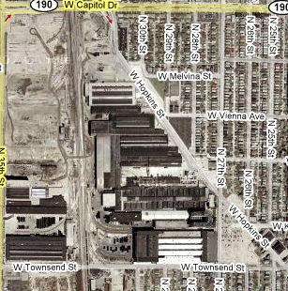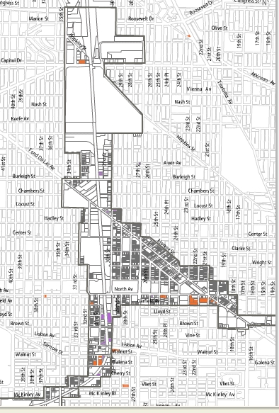
A.O.Smith/Tower Automotive Site 30th St Industrial Corridor Boundary
Redevelopment Challenges
The ability of local residents to influence cleanup and redevelopment decisions at the site is complicated by a number of factors. First, ownership of the site is fragmented. Properties on the southwest of the site have been bought by private investors. Current operations there include a recycling plant, warehouses, and distribution centers. On the western portion of the site, the city opened a 230,000-square-foot Public Works Department facility that currently employs some 300 people. But most important, 86 acres on the eastern side of the site, with some 2.2. million square feet of industrial space, was recently purchased by Milwaukee Industrial Trade Center LLC, an investor group led by Midwest Rail and Dismantling Co. The intentions of this group are unclear. Some local residents are concerned that the site will be divided into smaller parcels or leased to various businesses, such as warehousing or distribution centers, that provide relatively few good jobs. Others believe that the investor group, aware of the city’s interest in buying the property, is willing to sit on the site until the city meets its sales price, thus adding more uncertainty to the redevelopment process.
Second, while the city and DNR have been able to assess the environmental conditions of some 20 sites in the corridor, they have not done so for the A.O. Smith/Tower site. Thus, they do not have a detailed picture of possible contamination issues. The corridor properties where assessments have been conducted are either city-owned or tax-delinquent. At these sites, the city has the authority to issue inspection warrants to gain access, conduct site assessments, and if need be, undertake sampling. By contrast, the A.O. Smith/Tower site has been in private hands for a century. Over the past few decades, the DNR has investigated various company-reported hazardous chemical spills, but there has not been, to our knowledge, any site-wide assessment or systematic sampling to determine the nature and extent of contamination. After a century of heavy industry, the site undoubtedly has some degree of contamination. But until community groups and others have a better handle on its severity, it is unclear what cleanup options are on the table, and how these options may hinder or facilitate reuse options for the property.
And third, the redevelopment of the A.O. Smith/Tower site is part of a complex set of issues that underpin local and state brownfield initiatives in the corridor: the critical lack of well paying jobs, the social and spatial isolation of inner city residents, the absence of meaningful regional equity policies, a weak real estate market, turf disputes between local, county and regional public agencies involved with community involvement and planning, and a history of mistrust between local non-white residents and the city.
Workshop Themes
GJLN organized the workshop, entitled a Tale of Two Cities, to give community residents a firsthand example of how neighbors, community-based organizations, and unions in Denver were able to influence the cleanup and redevelopment of a similar large brownfield site in Denver. That site, the Gates Rubber factory, resembles Milwaukee’s A.O. Smith/Tower site in size, scale, and historical significance. Until 1995, for example, the Gates Rubber factory in Denver employed five thousand workers. Like A.O. Smith, it had been the economic backbone of minority neighborhoods for decades. And its closure led to the loss of good jobs and consequent decline of the entire area.
After introductory remarks about the A.O. Smith/Tower site by GJLN Executive director Pam Fendt and presentations by CPEO staff on brownfield cleanup and redevelopment issues, Tim Lopez, a Denver community activist, took the floor. A leader of the the Campaign for Responsible Development, a broad and influential community coalition, Lopez described its work at the Gates Rubber site.
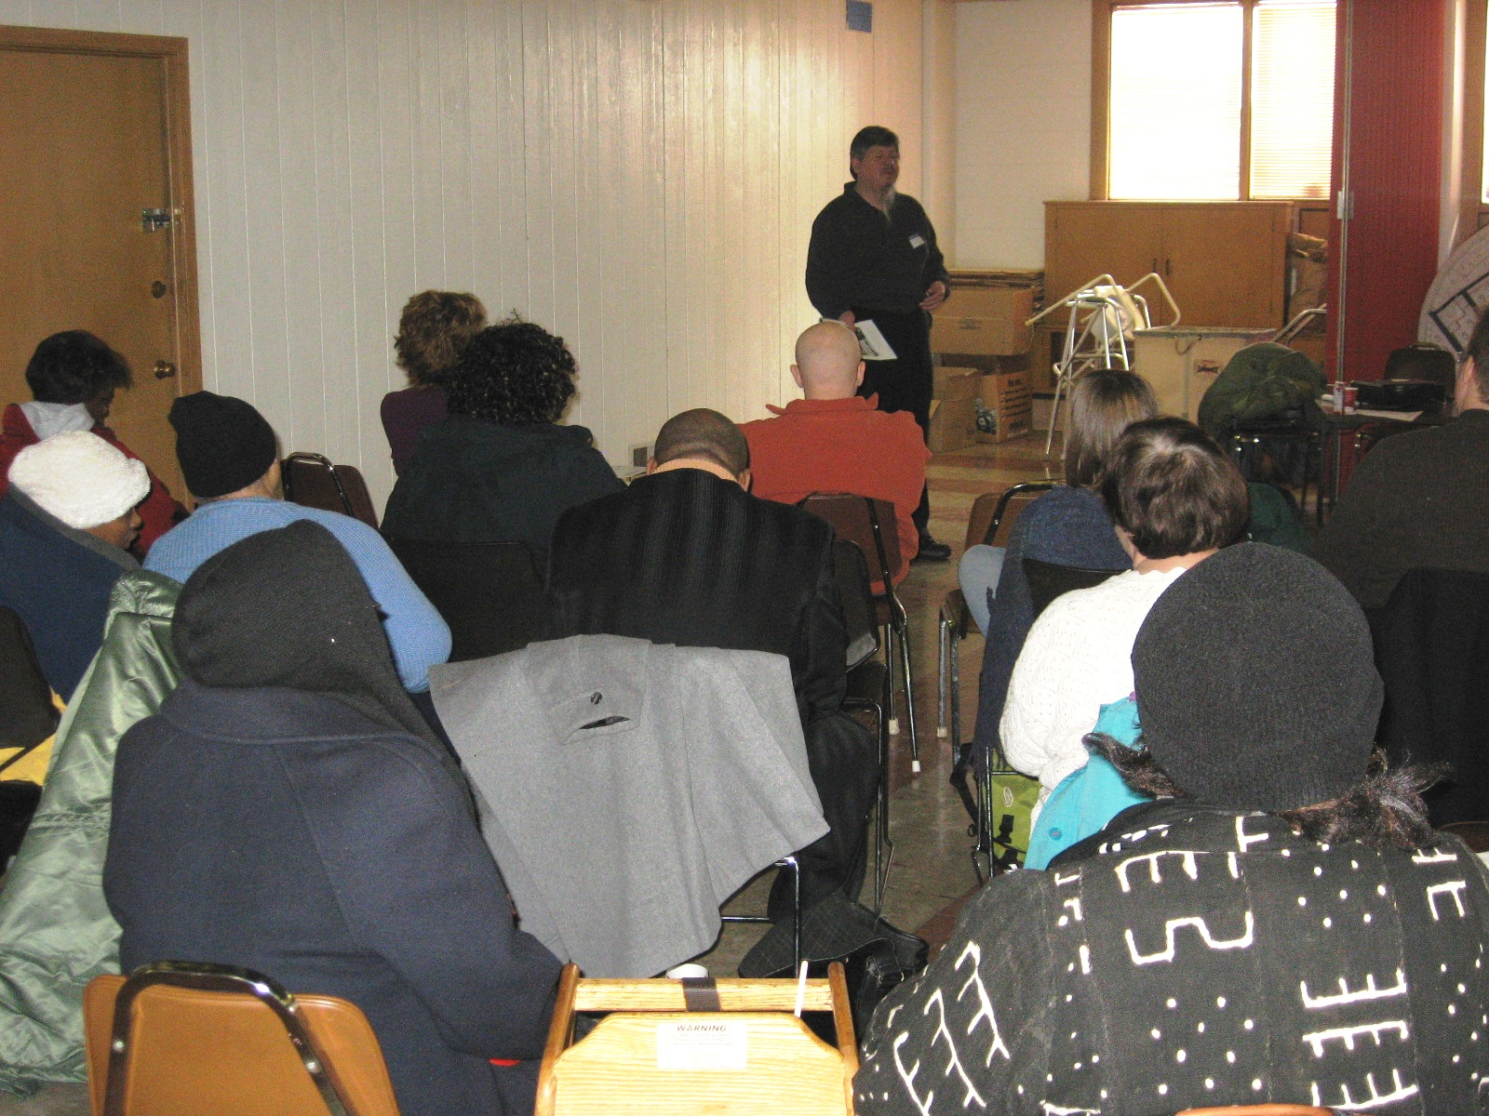
Tim Lopez
Tim discussed how the community coalition in Denver negotiated a benefits package with the city and the developer of the Gates Rubber factory, Cherokee Denver, to ensure that residents of adjacent neighborhoods benefited from the site’s redevelopment. Although it took four years and many, many hours to finalize, the benefits package with the city and the developer included prevailing wage provisions, 350 affordable housing units, a more accessible and attractive development, and decent paying jobs for people in the neighborhood. The agreement also helped to create a voluntary cleanup advisory board to oversee investigation, remediation, and long-term site management.

According to Lopez, the community coalition was successful because it negotiated with elected officials and the developer with a single voice and a single set of demands. During these negotiations, Cherokee Denver sought approval of some 126 million dollars in public subsidies to go forward with the project. The coalition used its political clout to convince Cherokee that it could help it obtain government subsidies if the developer would incorporate the coalition’s demands into its plans. Since the package was finalized in 2006, Cherokee has more recently agreed to provide jobs that pay competitive wages for local residents in both the construction and retail industries.

Workshop participants appeared inspired by the Denver model. At the end of the workshop Jennifer Epps, a GJLN community organizer, led a spirited discussion about community organizing strategies that could build on the momentum and enthusiasm of the workshop—following up on several of Lopez’s suggestions. Clearly, Milwaukee activists are well aware that implementing a community benefits package at the A.O.Smith/Tower site will not be easy or straightforward. It will require considerable commitment and dedication over several years. The December 8 workshop was a robust first step along this road.

